**Best Keyword Cover Search**

**Concept of BKC**: Best Keyword Cover which considers inter-objects **DISTANCE** as well as the keyword **RATING** of objects.

This concept id inspired by the methods of Closest Keywords search which is based on combining objects from different query keywords to generate candidate keyword covers like Hotel, Restaurant, and Bar.

We achieved moral of BKC concept by using **keyword-NNE algorithm**. By using Apriori algorithm

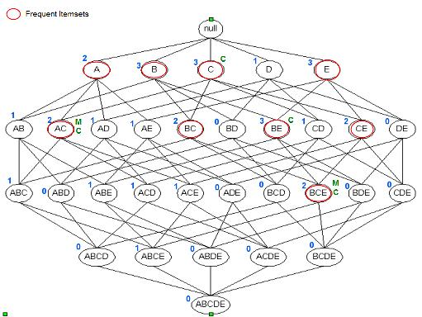

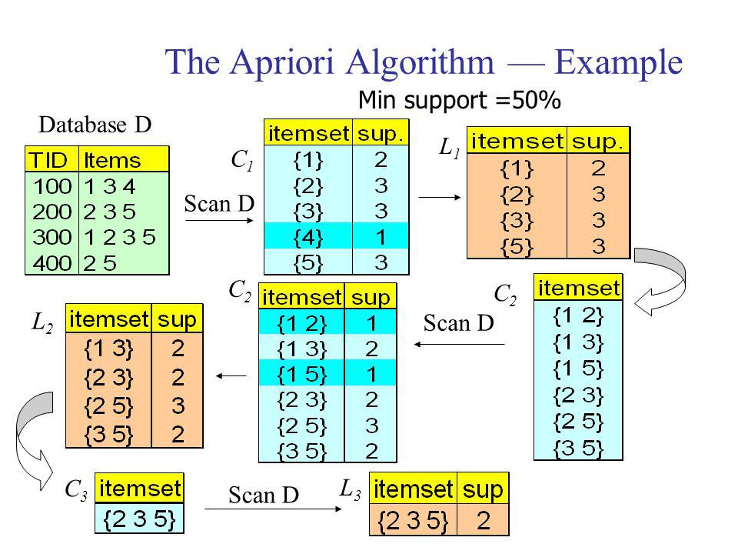

**Here Min Sup we taken Distance (5.0 km min) and Rating (6/10 min)**